Veeva Integrated Program GrandTest

Q6 : Demonstrate how to handle failed tests in xray

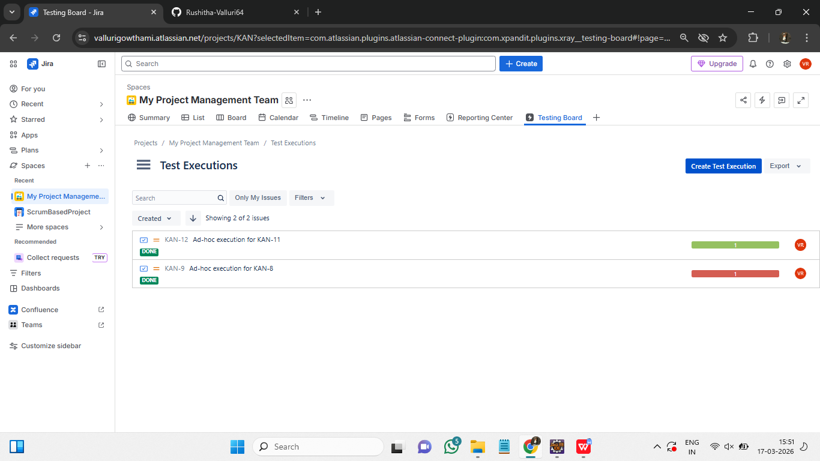

Steps to demonstrate how to handle failed tests in xray :
- Go to Jira Test Execution Issue and open the tests.
- Identify the failed tests as its status will be shown as FAILED.
- Click on the failed tests and check the execution details.
- Inside the test, create a bug and link it to the test.
- Assign the bug to a developer and set priority.
- Retest the bug after it is fixed and update the status.

